**Bags:**

CODE Bag 0076

1

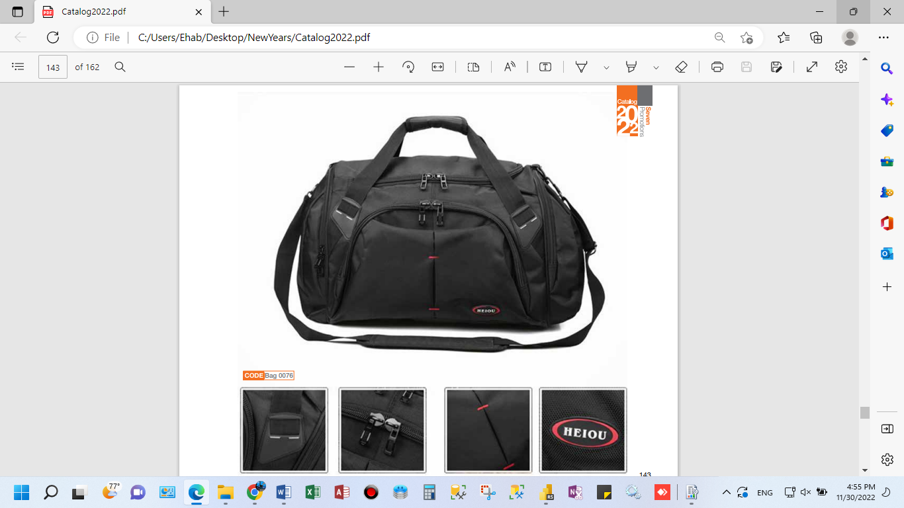

Pens:

CODE PP 3022

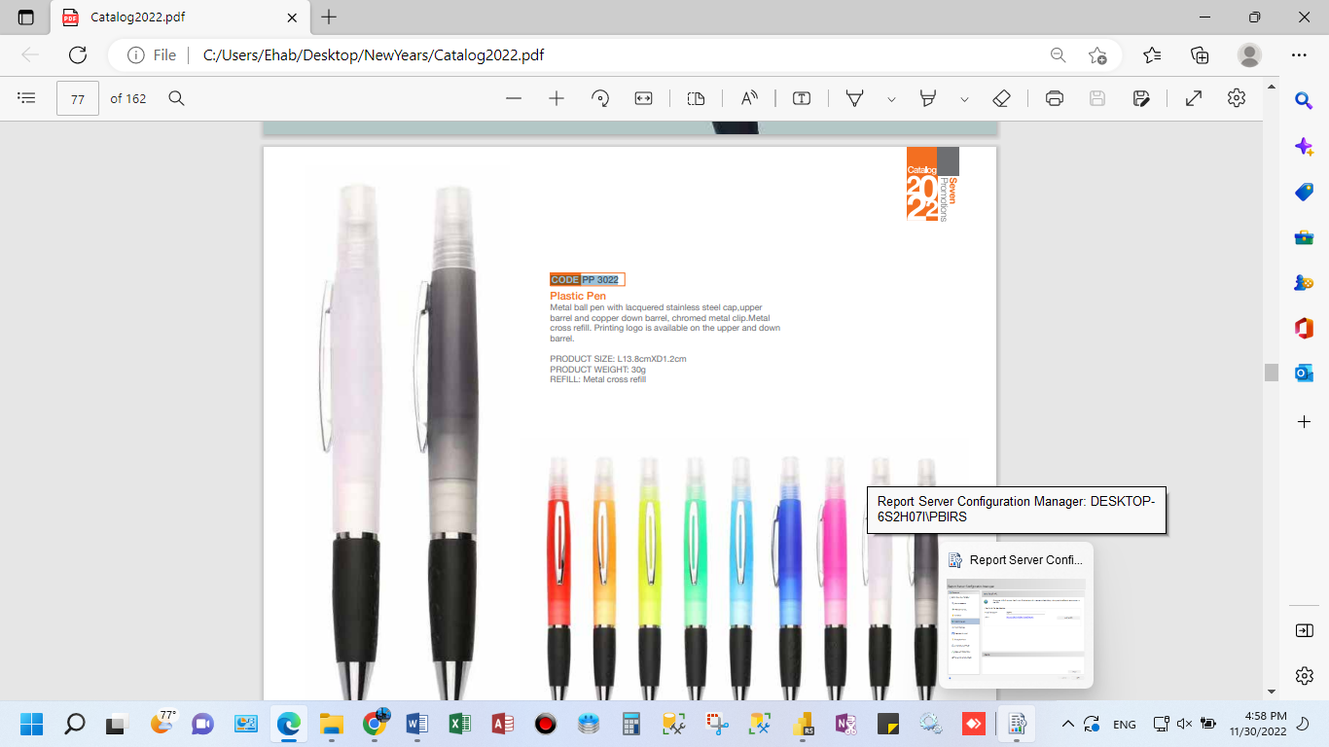

Aluminum Pens:

CODE MP 2025

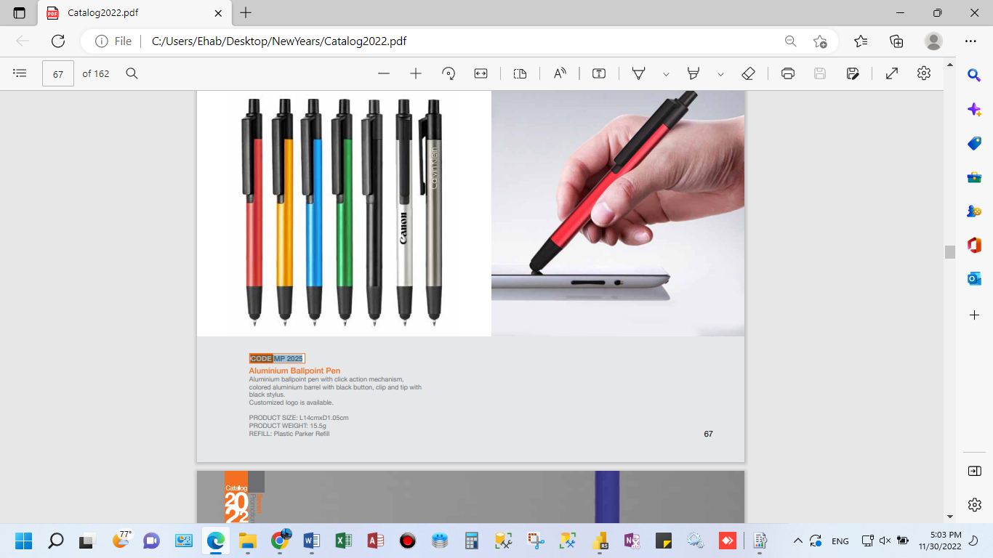

USB Flash Pen:

CODE FP 4001

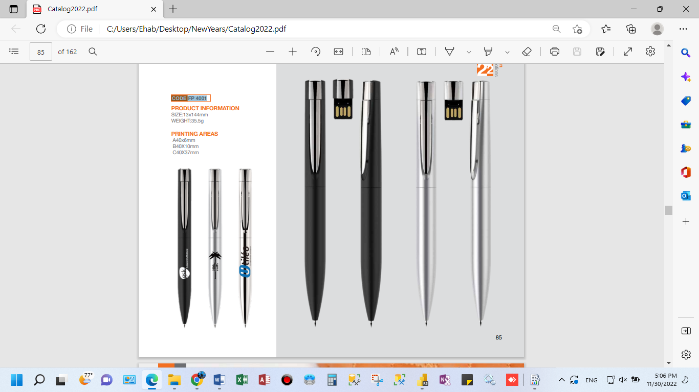

USB Flash drive

CODE FM 0015

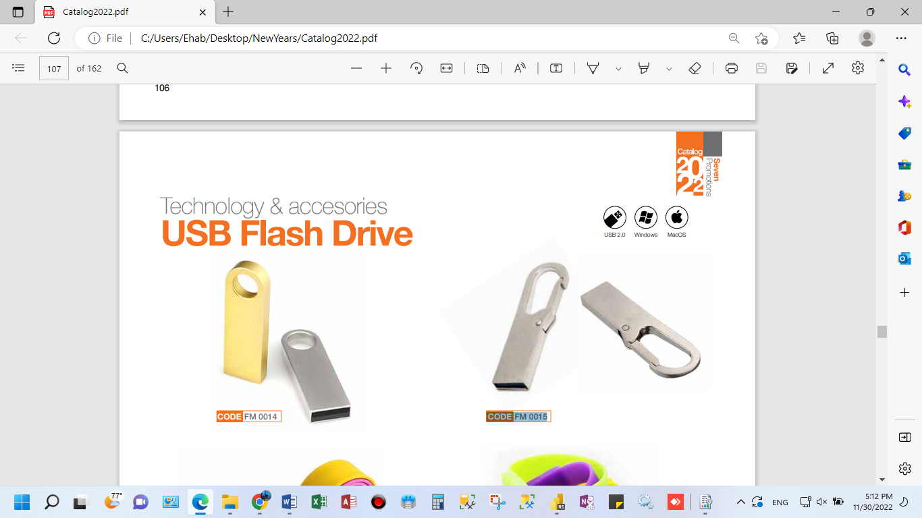

CODE FM 0007

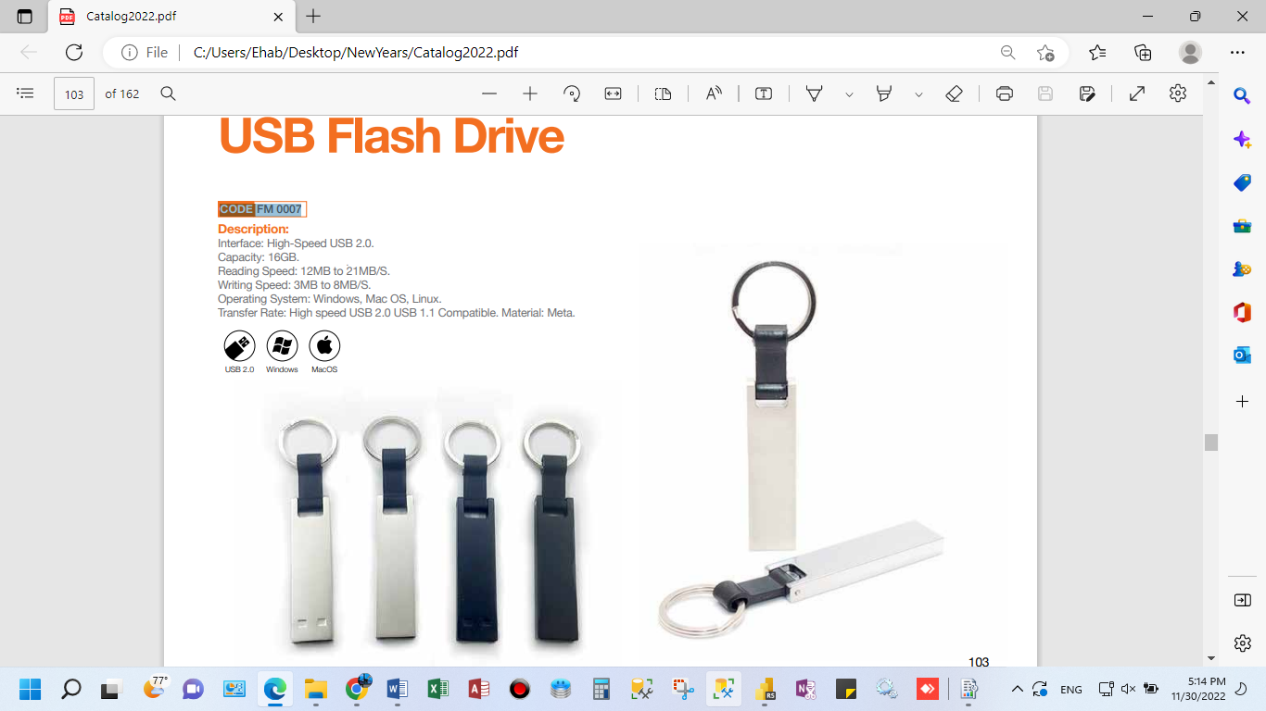

CODE FM 0002

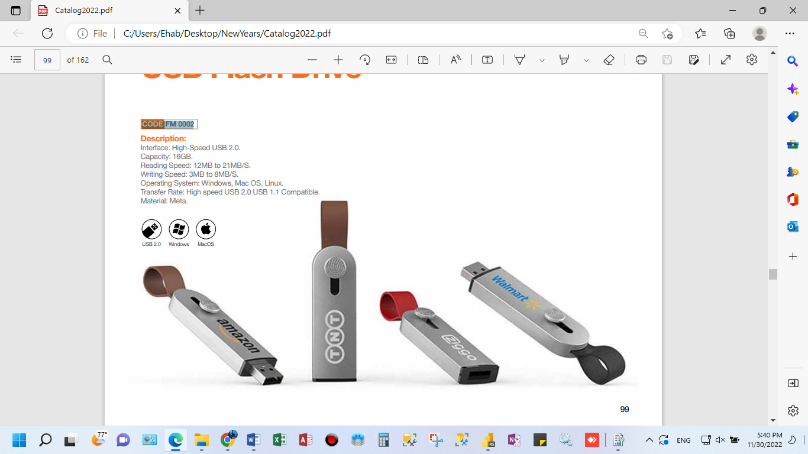

Note Book:

CODE NB 1005

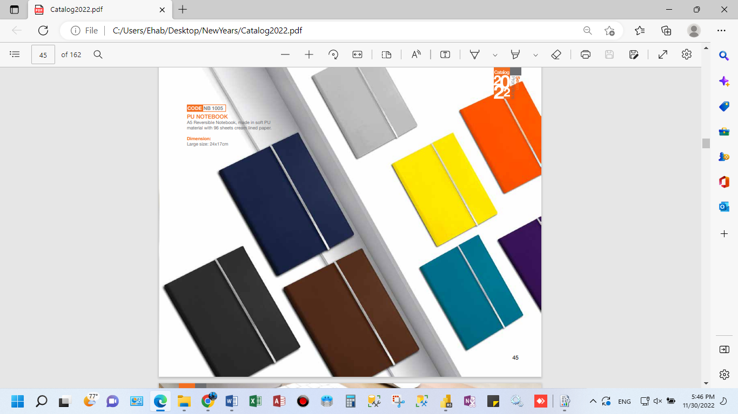

CODE NB 1004

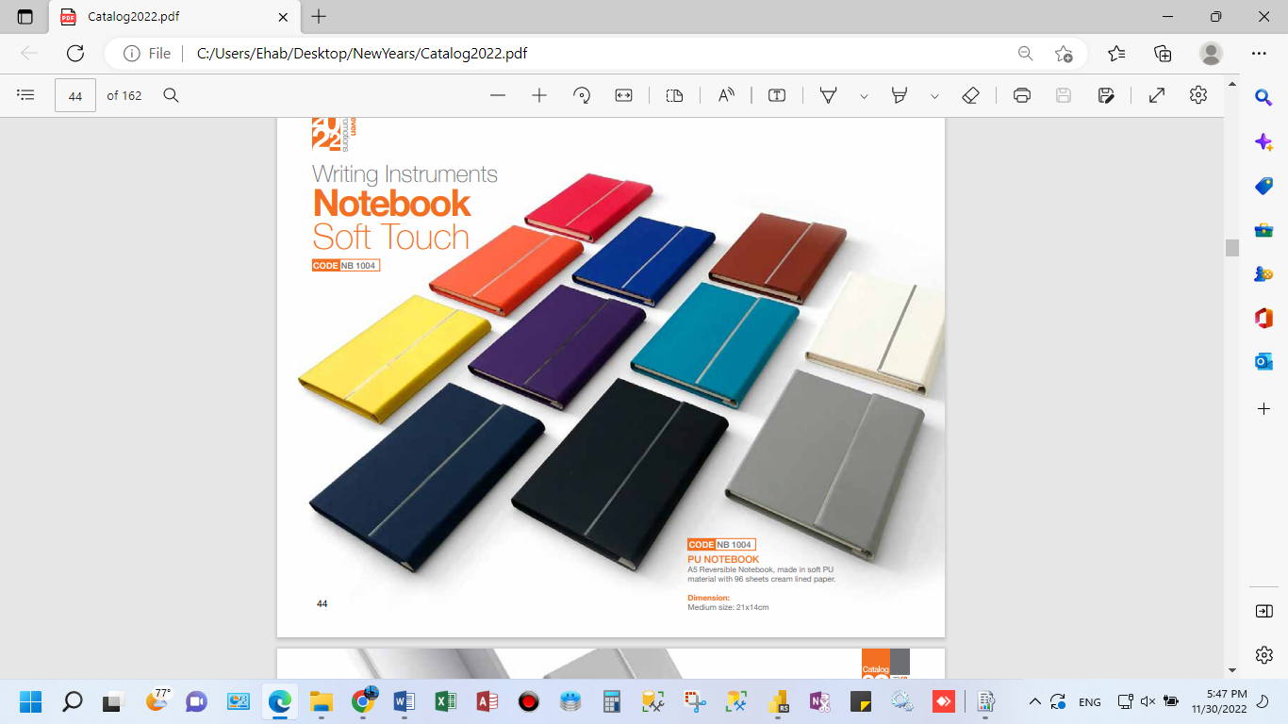

Gift Set

CODE GS 2012

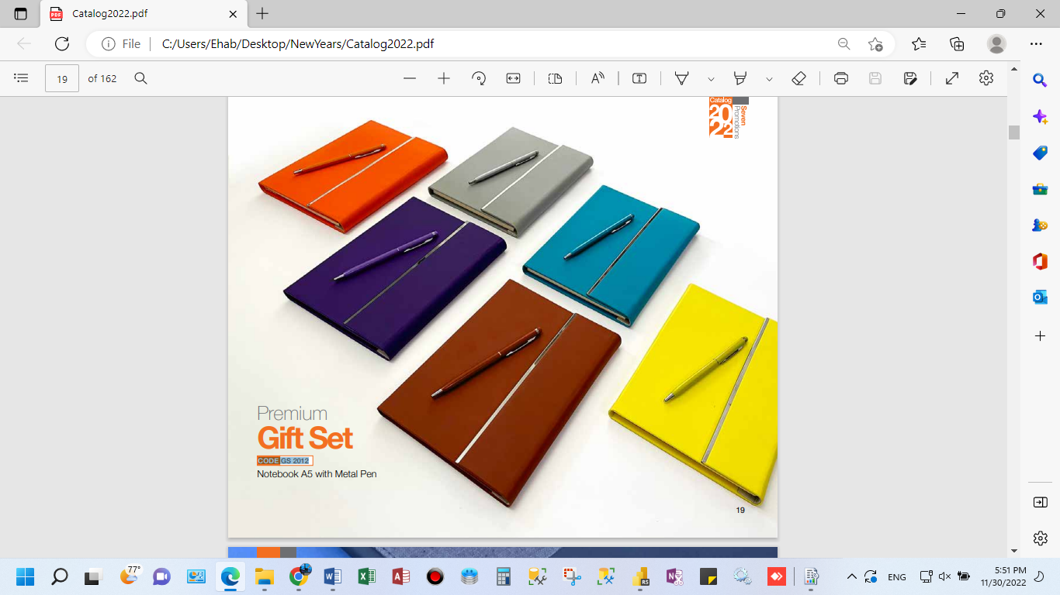

CODE GS 2009

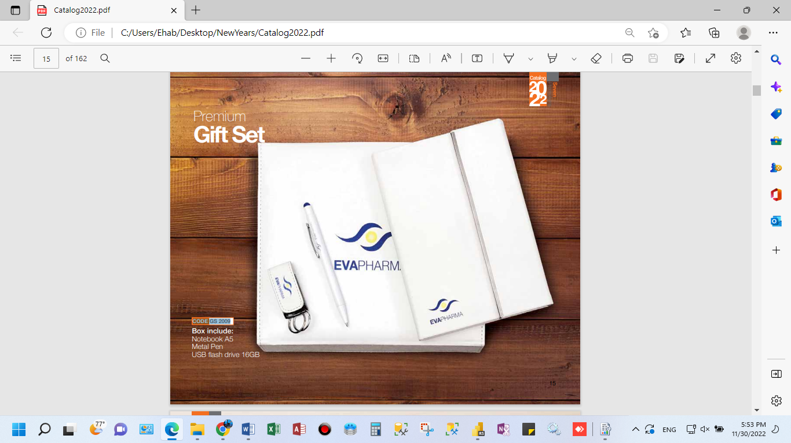

GS 2003

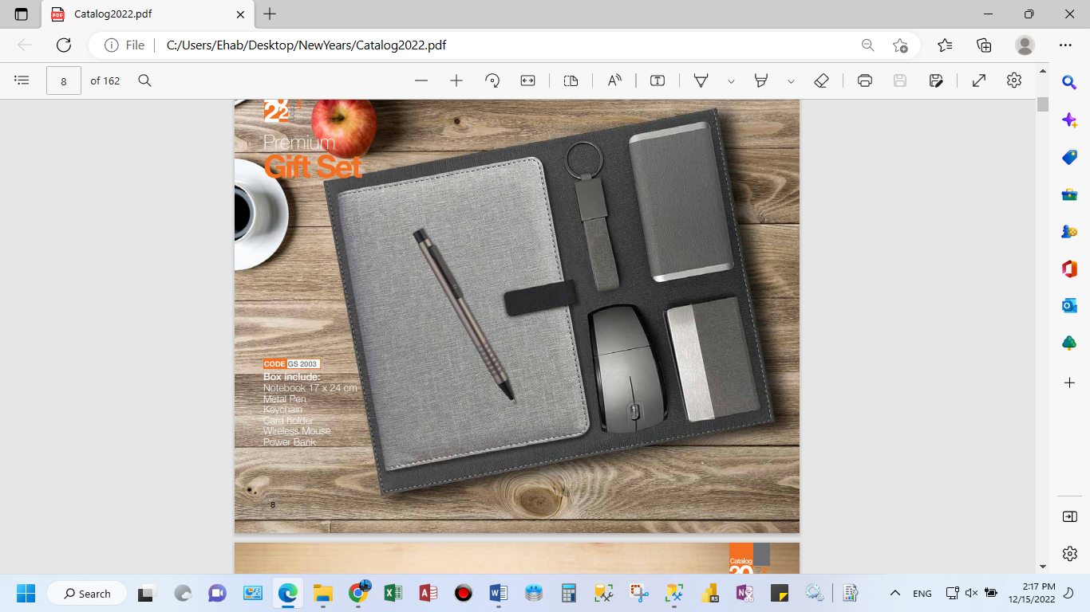

|  |  |  |
| --- | --- | --- |
| Price/50 unit | Code | Quantity |
|  | CODE GS 2003 | 50 |
|  | ODE GS 2002 | 50 |
|  | CODE NB 0999 | 50 |
|  | CODE NB 1001 | 50 |
|  | CODE GS 2009 | 50 |
|  | CODE GS 2012 | 50 |
|  | CODE NB 1004 | 50 |
|  | CODE NB 1005 | 50 |
|  | CODE FM 0002 | 50 |
|  | CODE FM 0007 | 50 |
|  | CODE FM 0015 | 50 |
|  | CODE FP 4001 | 50 |
|  | CODE MP 2025 | 50 |
|  | CODE PP 3022 | 50 |
|  | CODE Bag 0076 | 20 |